Python API Challenge Analysis

1. The first observable trend noted in Part I of the assignment is unsurprising: it gets hotter as we approach the equator! One of the stated goals of the assignment was to demonstrably *prove* if it gets hotter, and I think I was able to do just that. See the image below:

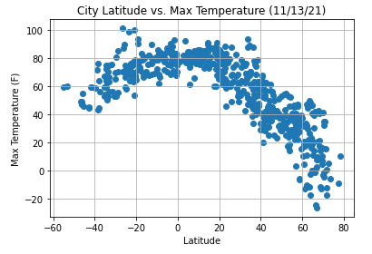

This scatter plot clearly demonstrates that, as we approach 0 degrees latitude, temperature increases!

1. The second observable trend noted in Part I is that there appears to be an increase in wind speed as we venture further away from the equator. See below:

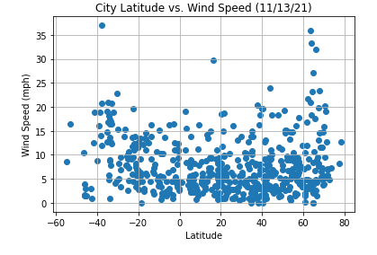

The gentle U shape of the scatter plot leads me to believe that the lack of prominent geographic features near the polar regions may not restrict atmospheric flow, leading to higher wind conditions.

1. Finally, the data did not display any significant relationships between latitude and cloudiness. As I stated in the notebook, this may be due to the variations in humidity between costal/non-costal regions. I would be interested in exploring this further and seeing if there are any transformations that could be applied to better sort and fit the data to a model.